**Saint George 2025 Greek Orthodox Festival Sponsorship Form**

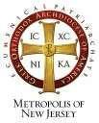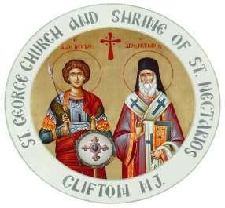 **Saint George Greek Orthodox Church**

**and the Shrine of St Nectarios**

**818 Valley Road, Clifton New Jersey 07013**

**Telephone No: 973-779-262 Fax No: 973-777-6946**

**E-mail: O**[**FFICE@STGEORGECLIFTON.ORG**](mailto:FFICE@STGEORGECLIFTON.ORG)

|  |  |  |
| --- | --- | --- |
| ☐ | FRIENDS AND FAMILY | $100.00 |
|  | * For individuals, Families and small Businesses * Name listed on the Menu as a Sponsor | |
| ☐ | SPONSOR | $500.00 |
|  | * 3’ x 2’ Banner -Your Company’s Logo or write special message. * Banner will be displayed on the Festival Grounds * Name listed on the Menu as a Sponsor | |
| ☐ | PREMIUM SPONSOR | $750.00 |
|  | * 4’ x 3’ Banner - Your Company’s logo or write a special message. * Banner will be displayed on the Festival Grounds * Name listed on the Menu as a Sponsor | |
| ☐ | GRAND SPONSOR | $1,000.00 |
|  | * 5’ x 3’ Banner - Your Company’s logo or write a special message. * Banner will be displayed on the Festival Grounds * Name listed Menu as a Sponsor | |

**Please make checks payable to St. George Greek Orthodox Church.**

**Please indicate “Festival Sponsor” in the memo line.**

|  |  |  |  |  |  |  |
| --- | --- | --- | --- | --- | --- | --- |
| Name of Sponsor: | |  | | | | |
|  | | | | | | |
| Contact Name: | |  | Tel: |  | Email: |  |
|  | | | | | | |
| Website: |  |  | | | | |

**Thank you for your generous support.**